**LAB NAME : AI ASSISTED CODING**

**LAB NUMBER :04**

**ROLL NO :2503A51L28**

**BRANCH : CSE**

**NAME : A.Abhiram**

**TASK 1**

**Task Description:** **Write a class definition comment and start the constructor for a class called BankAccount with account_holder and balance attributes. Use GitHub Copilot to auto-complete the rest of the class, including methods to deposit, withdraw, and display balance.**

**PROMPT:** **Create a Python class named BankAccount with attributes account_holder and balance.Implement a constructor to initialize these attributes.**

**deposit(amount): adds the amount to the balance. withdraw(amount): subtracts the amount if sufficient balance exists. display_balance(): prints the account holder's name and current balance**

**CODE:** 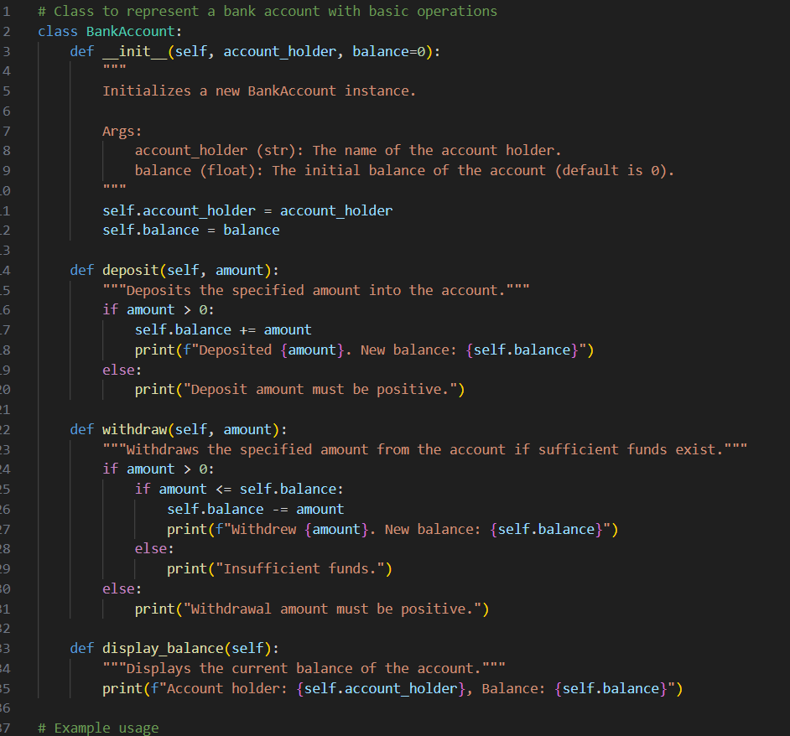

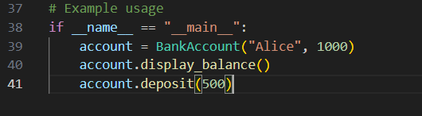

**OUTPUT:**

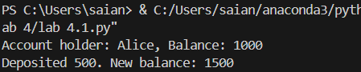

**TASK 2**

**Task Description:** **Write a comment and the initial line of a loop to iterate over a list. Allow GitHub Copilot to complete the logic to sum all even numbers in the list.**

**PROMPT: Write Python code to iterate over a list of integers and calculate the sum of all even numbers. Start by defining a list called 'numbers' with some sample values.Use a loop to check each number and add it to a running total if it's even. Finally, print the total sum of even numbers.**

**CODE:**

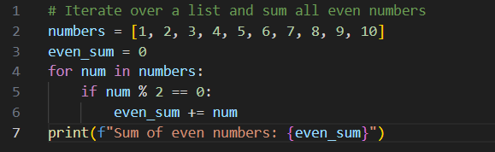

**OUTPUT:**

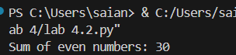

**TASK 3**

**Task Description:** **Start a function that takes age as input and returns whether the person is a child, teenager, adult, or senior using if-elif-else. Use Copilot to complete the conditionals.**

**PROMPT:** **# Write a Python function called classify_age that takes an integer 'age' as input.**

**# Use if-elif-else statements to return one of the following strings based on the age:**

**# - "Child" if age is 12 or below**

**# - "Teenager" if age is between 13 and 19**

**# - "Adult" if age is between 20 and 64.**

**#- "Senior" if age is 65 or above**

**CODE:**

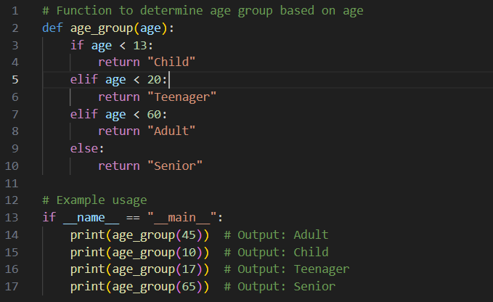

**OUTPUT:**

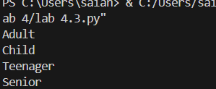

**TASK 4**

**TASK DESCRITION:** **Write a comment and start a while loop to reverse the digits of a number. Let Copilot complete the loop logic**

**PROMPT:**  **Write Python code to reverse the digits of a given positive integer using a while loop.Start by initializing a variable 'num' with a sample value Use a while loop to extract digits and build the reversed number.Print the final reversed number.**

**num = 12345**

**CODE:** 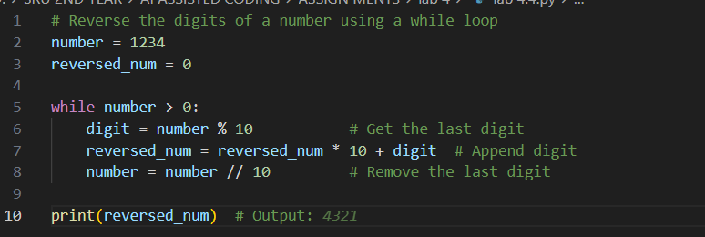

OUTPUT:

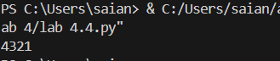

**TASK 5**

**TASK DESCRIPTION:** **Begin a class Employee with attributes name and salary. Then, start a derived class Manager that inherits from Employee and adds a department. Let GitHub Copilot complete the methods and constructor chaining.**

**PROMPT:** **Create a Python class called `Employee` with attributes `name` and `salary`. Define an `__init__` method to initialize these attributes. Then, create a derived class called `Manager` that inherits from `Employee` and adds an additional attribute `department`. Use constructor chaining to initialize the base class attributes from the derived class. Add a method in each class to display the details of the employee or manager. Complete the implementation.**

**CODE:** 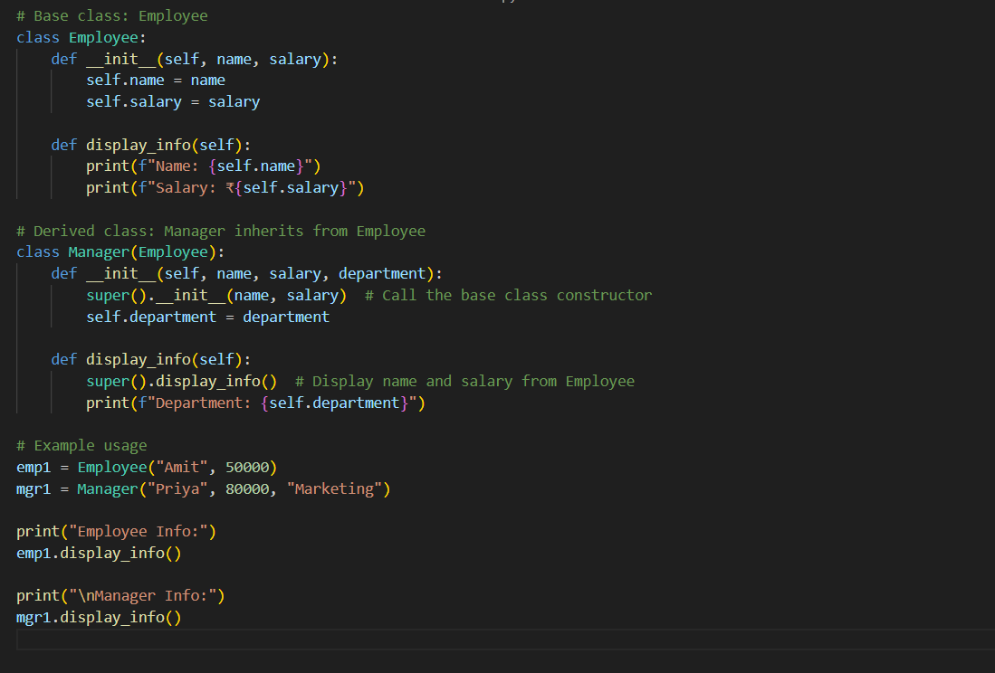

OUTPUT:

